**Firmware Upload**

Followed these instructions: <https://ardupilot.org/copter/docs/common-loading-firmware-onto-chibios-only-boards.html>

Firmware is labeled matek-f405 (no CTR specific tag)

Used STM32CubeProgrammer for flashing. Can also use Betaflight to flash.

STM32CubeProgrammer was finicky on Linux Mint. Used my surface with Windows 10.

**Wiring**

**Default UART order**

* SERIAL0 = console = USB
* SERIAL1 = Telemetry1 = USART3
* SERIAL2 = Telemetry2 = UART4
* SERIAL3 = GPS1 = USART1
* SERIAL4 = GPS2 = UART5
* SEIRAL5 = User = USART2 (TX only unless [BRD_ALT_CONFIG](https://ardupilot.org/copter/docs/parameters.html#brd-alt-config) = 1, then RX is available)

GPS Wiring

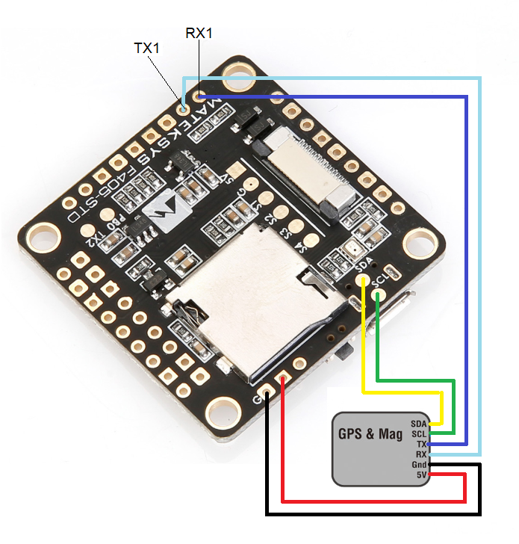

Note: This is the STD, the CTR looks a little different, but still use UART1 for GPS and I2C for compass

No power to GPS module?? Needs battery to use 5 V rail. Gotta be outside for GPS fix